http://unix.stackexchange.com/questions/34334/how-to-create-a-user-with-limited-ram-usage

How to create a user with limited RAM usage?
up vote9down votefavorite  2 | So I have 4 GB RAM + 4GB swap. I want to create a user with limited ram and swap: 3 GB RAM and 1 GB swap. Is such thing possible? Is it possible to start applications with limited RAM and swap avaliable to them without creating a separate user (and not installing any special apps - having just a default Debian/CentOS server configuration, and not using sudo)?  Update:  So I opened terminall and typed into it ulimit command: ulimit -v 1000000 which shall be like976,6Mb limitation. Next I called ulimit -a and saw that limitation is "on". Then I started some bash script that compiles and starts my app in nohup, a long one nohup ./cloud-updater-linux.sh >& /dev/null &... but after some time I saw:  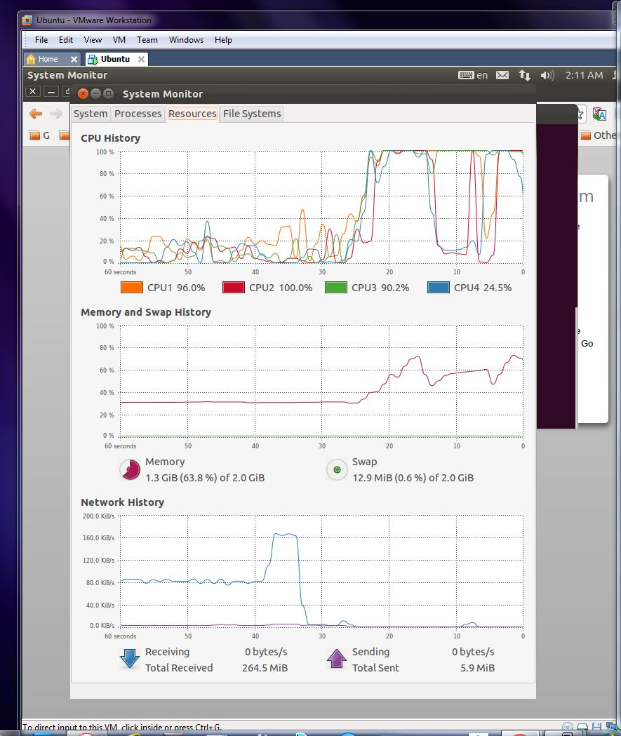  (which would be ok if no limitations were applied - it downloaded some large lib, and started to compile it.)  But I thought I applied limitations to shall and all processes launched with/from it with ulimit -v 1000000? What I got wrong? How to make a terminal and all sub processes it launches be limited on ram usage?  users memory not-root-user limit  shareimprove this question edited Mar 16 '12 at 23:28  Gilles 159k21192421 asked Mar 16 '12 at 12:54  myWallJSON 33639
 | You can't put memory restrictions on a user as a whole, only on each process. And you can't distinguish between RAM and swap usage. If you want finer control, run the user's processes in a virtual machine. – GillesMar 16 '12 at 23:30

2 Answers
activeoldestvotes
up vote17down voteaccepted | ulimit is made for this. You can setup defaults for ulimit on a per user or a per group basis in  /etc/security/limits.conf  ulimit -v KBYTES sets max virtual memory size. I don't think you can give a max amount of swap. It's just a limit on the amount of virtual memory the user can use.  So you limits.conf would have the line (to a maximum of 4G of memory)  luser hard as 4000000  UPDATE - CGroups  The limits imposed by ulimit and limits.conf is per process. I definitely wasn't clear on that point.  If you want to limit the total amount of memory a users uses (which is what you asked). You want to use cgroups.  In /etc/cgconfig.conf:  group memlimit {  memory {  memory.limit_in_bytes = 4294967296;  }  }  This creates a cgroup that has a max memory limit of 4GiB.  In /etc/cgrules.conf:  luser memory memlimit/  This will cause all processes run by luser to be run inside the memlimit cgroups created incgconfig.conf.  shareimprove this answer edited Mar 19 '12 at 13:16 answered Mar 16 '12 at 13:09  utopiabound 1,34429
 | is such thing settable on useradd? – myWallJSON Mar 16 '12 at 13:41
3 | @myWallJSON Not directly, but you can immediately add it to limits.conf, or you can setup a group with certain limits in limits.conf and add user to that group. – utopiabound Mar 16 '12 at 14:56
1 | That's awesome! I didn't know you could do this! Great answer +1 – Yanick Girouard Mar 16 '12 at 16:50
 | @utopiabound: Updated my Q with some data I got trying to use ulimit. – myWallJSON Mar 16 '12 at 22:24
1 | @f.ardelian Upgrade the kernel. Here's an article about how to do just that! – Daniel C. Sobral Feb 11 at 1:05
show 2 more comments

up vote1down vote | You cannot cap memory usage at the user level, ulimit can do that but for a single process.  Even with using per user limits in /etc/security/limits.conf, a user can use all memory by running multiple processes.  Should you really want to cap resources, you need to use a resource management tool, like rcapdused by projects and zones under Solaris.  There is something that seems to provide similar features on Linux that you might investigate:cgroups.

http://superuser.com/questions/48505/how-to-find-virtual-memory-size-and-cache-size-of-a-linux-system

How to find virtual memory size and cache size of a linux system?
up vote3down votefavorite  2 | Is there any command to get virtual memory size, cache size and front side bus speed of a linux system? Is swap in linux same as virtual memory?  linux memory virtual-memory  share|improve this question edited Sep 29 '09 at 14:06  joe 8,04743781 asked Sep 29 '09 at 13:47  pineapple 3442823
 | swap == virtual memory – Joakim Elofsson Sep 29 '09 at 13:49
 | Please give the specs of your CPU. Open the bios from startup of your system to determine your CPU's FSB. Or just google the model of your CPU. If you have a desktop PC, you could open the case and look at the cpu directly to find the model. – Jonno_FTW Sep 30 '09 at 7:46
2 | No, swap and virtual memory are completely different. For example, memory mapping a 1GB file uses an additional 1GB of virtual memory but has no change in the use of swap. Swap is a form of backing store. Many uses of virtual memory don't have anything to do with backing store. (And there have been systems with virtual memory and no swap as well as systems with swap but no virtual memory.) – David SchwartzFeb 18 at 16:52

9 Answers
activeoldestvotes
up vote5down voteaccepted | This question is completely contained in your previous question How to find virtual memory size and cache size of a linux system?. As pointed out in my answer to that question, the sudo dmidecode --type processor command gives you the "External Clock" speed, and FSB speed is a multiple(typically 2 or 4 times) of this speed.  If this did not work for you, you should edit your original question and tell us what output you got or what the error was. The more specific you are, the better others can help you.  As pointed out by The Journeyman geek, you can typically get the same "External Clock" measure fromlshw, in the value reported for "clock" in the cpu related ouput.  *-cpu  description: CPU  product: Genuine Intel(R) CPU T2300 @ 1.66GHz  vendor: Intel Corp.  physical id: 400  bus info: cpu@0  version: 6.14.8  serial: 0000-06E8-0000-0000-0000-0000  slot: Microprocessor  size: 1GHz  capacity: 1800MHz  width: 32 bits  clock: 133MHz  capabilities: fpu fpu_exception wp vme de pse tsc msr pae mce cx8 apic sep mtrr pge mca cmov pat clflush dts acpi mmx fxsr sse sse2 ss ht tm pbe nx constant_tsc arch_perfmon bts pni monitor est tm2 xtpr pdcm cpufreq  configuration: id=0  Finally, you may find the external clock speed in the output of dmesg, though this is by no means a standard way of accessing this information. You may find the FSB speed via your BIOS settings, or by looking up your CPU spec, though these are not linux specific.  share|improve this answer answered Sep 30 '09 at 8:24  nagul 13k13454

up vote5down vote | Yes, swap is virtual memory.  Virtual memory size Use swapon -s or free  $ swapon -s  Filename Type Size Used Priority  /dev/sda6 partition 1004020 39620 -1  $ free  total used free shared buffers cached  Mem: 3087892 2879036 208856 0 394288 835052  -/+ buffers/cache: 1649696 1438196  Swap: 1004020 39620 964400  Cache size Get this from /proc/cpuinfo. The "cache size" field gives you the cache on the CPU. On multi-core machines, you'll see one entry per processor, with its own cache value.  $ cat /proc/cpuinfo  processor : 0  vendor_id : GenuineIntel  cpu family : 6  model : 14  model name : Genuine Intel(R) CPU T2300 @ 1.66GHz  stepping : 8  cpu MHz : 1000.000  cache size : 2048 KB  physical id : 0  siblings : 2  core id : 0  cpu cores : 2  apicid : 0  initial apicid : 0  fdiv_bug : no  hlt_bug : no  f00f_bug : no  coma_bug : no  fpu : yes  fpu_exception : yes  cpuid level : 10  wp : yes  flags : fpu vme de pse tsc msr pae mce cx8 apic sep mtrr pge mca cmov pat clflush dts acpi mmx fxsr sse sse2 ss ht tm pbe nx constant_tsc arch_perfmon bts pni monitor est tm2 xtpr pdcm  bogomips : 3324.64  clflush size : 64  power management:  Front side bus (FSB) speed You can get this from the dmidecode utility, with the --type processorargument. You need sudo permission to run this command. The FSB is indicated by the speed reported for "External Clock". The actual speed is typically 4 times the reported speed, as those many instructions are executed per clock cycle.  $ sudo dmidecode --type processor  # dmidecode 2.9  SMBIOS 2.4 present.  Handle 0x0400, DMI type 4, 32 bytes  Processor Information  Socket Designation: Microprocessor  Type: Central Processor  Family: Pentium M  Manufacturer: Intel  ID: E8 06 00 00 FF FB E9 BF  Signature: Type 0, Family 6, Model 14, Stepping 8  Flags:  FPU (Floating-point unit on-chip)  VME (Virtual mode extension)  DE (Debugging extension)  PSE (Page size extension)  TSC (Time stamp counter)  MSR (Model specific registers)  PAE (Physical address extension)  MCE (Machine check exception)  CX8 (CMPXCHG8 instruction supported)  APIC (On-chip APIC hardware supported)  SEP (Fast system call)  MTRR (Memory type range registers)  PGE (Page global enable)  MCA (Machine check architecture)  CMOV (Conditional move instruction supported)  PAT (Page attribute table)  CLFSH (CLFLUSH instruction supported)  DS (Debug store)  ACPI (ACPI supported)  MMX (MMX technology supported)  FXSR (Fast floating-point save and restore)  SSE (Streaming SIMD extensions)  SSE2 (Streaming SIMD extensions 2)  SS (Self-snoop)  HTT (Hyper-threading technology)  TM (Thermal monitor supported)  PBE (Pending break enabled)  Version: Not Specified  Voltage: 3.3 V  External Clock: 133 MHz  Max Speed: 1800 MHz  Current Speed: 1000 MHz  Status: Populated, Enabled  Upgrade: None  L1 Cache Handle: 0x0700  L2 Cache Handle: 0x0701  L3 Cache Handle: Not Provided  share|improve this answer answered Sep 29 '09 at 14:24  nagul 13k13454
I have linux, it does not have dmidecode/lshw command – pineapple Sep 30 '09 at 14:38
Which distro are you running? – nagul Sep 30 '09 at 14:55
Also, do you have sudo access to run these commands on the machine? – nagul Sep 30 '09 at 14:58

up vote2down vote | I do believe lshw has that info. However not all distros have it (hint- next time PLEASE mention what distro and version you use. It helps a lot. Also helps to be specific about what you did so far. 'some command like' is not good enough)  share|improve this answer answered Sep 30 '09 at 7:58  Journeyman Geek 54k1077159

up vote2down vote | Try this on the Linux machine: cat /proc/pal/cpu0/cache_info  This will show something like:  Cache levels : 3  Unique caches : 5  Data Cache level 1:  Size : 16384 bytes  Attributes : WriteThrough  Associativity : 4  Line size : 64 bytes  Stride : 128 bytes  Store latency : 0 cycle(s)  Load latency : 1 cycle(s)  Store hints :  Load hints : [Temporal, level 1]  Alias boundary : 4096 byte(s)  Tag LSB : 12  Tag MSB : 49  Instruction Cache level 1:  Size : 16384 bytes  Attributes :  Associativity : 4  Line size : 64 bytes  Stride : 128 bytes  Store latency : N/A  Load latency : 1 cycle(s)  Store hints :  Load hints : [Temporal, level 1]  Alias boundary : 4096 byte(s)  Tag LSB : 12  Tag MSB : 49  Data Cache level 2:  Size : 262144 bytes  Attributes : WriteBack  Associativity : 8  Line size : 128 bytes  Stride : 128 bytes  Store latency : 7 cycle(s)  Load latency : 5 cycle(s)  Store hints : [Temporal, level 1][Non-temporal, all levels]  Load hints : [Temporal, level 1][Non-temporal, level 1][Non-temporal, all levels]  Alias boundary : 4096 byte(s)  Tag LSB : 15  Tag MSB : 49  Instruction Cache level 2:  Size : 524288 bytes  Attributes :  Associativity : 8  Line size : 128 bytes  Stride : 128 bytes  Store latency : N/A  Load latency : 7 cycle(s)  Store hints :  Load hints : [Temporal, level 1][Non-temporal, level 1][Non-temporal, all levels]  Alias boundary : 4096 byte(s)  Tag LSB : 16  Tag MSB : 49  Data/Instruction Cache level 3:  Size : 4194304 bytes  Attributes : Unified WriteBack  Associativity : 8  Line size : 128 bytes  Stride : 128 bytes  Store latency : 7 cycle(s)  Load latency : 14 cycle(s)  Store hints : [Temporal, level 1]  Load hints : [Temporal, level 1][Non-temporal, level 1]  Alias boundary : 4096 byte(s)  Tag LSB : 19  Tag MSB : 49  share|improve this answer edited Feb 11 '11 at 11:42  Arjan 17.1k54077 answered Feb 11 '11 at 11:37  Tom 211

up vote1down vote | vmstat  vmstat reports report virtual memory statistics, which has information about processes, swap, free, buffer and cache memory, paging space, disk IO activity, traps, interrupts, context switches and CPU activity. With vmstat command, administrators can has instantaneous reports on memory usage.  Syntax of vmstat  vmstat -[options] [delay count]  Example usage of vmstat  vmstat  Found here  share|improve this answer answered Sep 29 '09 at 13:59  joe 8,04743781
 | 1 up, better than my solution :D, gives more info – monkey_p Sep 29 '09 at 14:10

up vote1down vote | The "free" command will show you memory utilization, including what's actually being used vs what's in buffers / cache.  # free  total used free shared buffers cached  Mem: 3896252 3779044 117208 0 65788 1363972  -/+ buffers/cache: 2349284 1546968  Swap: 2097144 886836 1210308  The "dmidecode" command might give you some insight into the FSB speed.  share|improve this answer answered Sep 29 '09 at 14:17  perlguy9 894

up vote0down vote | swapon -s  The used field will indicate the amount currently in use  Filename Type Size Used Priority  /dev/sda5 partition 859436 0 -1  share|improve this answer answered Sep 29 '09 at 13:57  monkey_p 29115

up vote0down vote | Page Size :  $ getconf PAGESIZE  (or)  $ getconf PAGE_SIZE  Try  swapinfo or swapinfo -a  share|improve this answer edited Sep 29 '09 at 14:00 answered Sep 29 '09 at 13:51  joe 8,04743781

up vote0down vote | Try ulimit -a, on my machine it will show something like:  core file size (blocks, -c) 0  data seg size (kbytes, -d) unlimited  scheduling priority (-e) 0  file size (blocks, -f) unlimited  pending signals (-i) 31321  max locked memory (kbytes, -l) 64  max memory size (kbytes, -m) unlimited  open files (-n) 1024  pipe size (512 bytes, -p) 8  POSIX message queues (bytes, -q) 819200  real-time priority (-r) 0  stack size (kbytes, -s) 8192  cpu time (seconds, -t) unlimited  max user processes (-u) 31321  virtual memory (kbytes, -v) unlimited  file locks (-x) unlimited  Run free, on my machine the result is like this:  total used free shared buffers cached  Mem: 4024900 606472 3418428 0 85768 366980  -/+ buffers/cache: 153724 3871176  Swap: 3998716 0 3998716  I wrote this code to test how many threads a process can create:  #include<iostream>  #include<pthread.h>  #include<unistd.h>  #include<stdio.h>  using namespace std;  #define MAX_THREAD_NUM 1100  void * threadTest(void* arg){  while(true){  sleep(5);  }  pthread_exit(NULL);  }  int main(){  for(int i = 0;i< MAX_THREAD_NUM;i++){  pthread_t tid;  cout<<"create thread "<< i <<"... "<<endl;  int ret = pthread_create(&tid,NULL,&threadTest,NULL);  if(ret !=0){  perror("pthread_create error");  }  pthread_detach(tid);  }  while(true){  sleep(5);  }  return 0;  }  The result is like this:  create thread 378...  create thread 379...  create thread 380...  create thread 381...  create thread 382...  pthread_create error: Cannot allocate memory  create thread 383...  pthread_create error: Cannot allocate memory  create thread 384...  pthread_create error: Cannot allocate memory  create thread 385...  pthread_create error: Cannot allocate memory  create thread 386...  pthread_create error: Cannot allocate memory

http://www.linuxhowtos.org/Tips%20and%20Tricks/ulimit.htm

ulimit and sysctl
The ulimit and sysctl programs allow to limit system-wide resource use. This can help a lot in system administration, e.g. when a user starts too many processes and therefore makes the system unresponsive for other users.

Code Listing 1: ulimit example
# ulimit -a
core file size (blocks, -c) 0
data seg size (kbytes, -d) unlimited
file size (blocks, -f) unlimited
pending signals (-i) 8191
max locked memory (kbytes, -l) 32
max memory size (kbytes, -m) unlimited
open files (-n) 1024
pipe size (512 bytes, -p) 8
POSIX message queues (bytes, -q) 819200
stack size (kbytes, -s) 8192
cpu time (seconds, -t) unlimited
max user processes (-u) 8191
virtual memory (kbytes, -v) unlimited
file locks (-x) unlimited

All these settings can be manipulated. A good example is this bash forkbomb that forks as many processes as possible and can crash systems where no user limits are set:

Warning: Do not run this in a shell! If no limits are set your system will either become unresponsive or might even crash.

Code Listing 2: A bash forkbomb
$ :(){ :|:& };:

Now this is not good - any user with shell access to your box could take it down. But if that user can only start 30 processes the damage will be minimal. So let's set a process limit:

Gentoo Note: A too small number of processes can break the use of portage. So, don't be too strict.

Code Listing 3: Setting a process limit
# ulimit -u 30
# ulimit -a
…
max user processes (-u) 30
…

If you try to run the forkbomb now it should run, but throw error messages "fork: resource temporarily unavailable". This means that your system has not allowed the forkbomb to start more processes. The other options of ulimit can help with similar problems, but you should be careful that you don't lock yourself out - setting data seg size too small will even prevent bash from starting!

sysctl is a similar tool: It allows to configure kernel parameters at runtime. If you wish to keep settings persistent across reboots you should edit /etc/sysctl.conf - be aware that wrong settings may break things in unforeseen ways.

Code Listing 4: Exploring sysctl variables
# sysctl -a
…
vm.swappiness = 60
…

The list of variables is quite long (367 lines on my system), but I picked out vm.swappiness here. It controls how aggressive swapping will be, the higher it is (with a maximum of 100) the more swap will be used. This can affect performance a lot on systems with little memory, depending on load and other factors.

Code Listing 5: Reducing swappiness
# sysctl vm.swappiness=0
vm.swappiness = 0

The effects of changing this setting are usually not felt instantly. But you can change many settings, especially network-related, this way. For servers this can offer a nice performance boost, but as with ulimit careless usage might cause your system to misbehave or slow down. If you don't know what a variable controls, you should not modify it!

http://unix.stackexchange.com/questions/44985/limit-memory-usage-for-a-single-linux-process

Limit memory usage for a single Linux process
up vote27down votefavorite  3 | I'm running pdftoppm to convert a user-provided PDF into a 300DPI image. This works great, except if the user provides an PDF with a very large page size. pdftoppm will allocate enough memory to hold a 300DPI image of that size in memory, which for a 100 inch square page is 100*300 * 100*300 * 4 bytes per pixel = 3.5GB. A malicious user could just give me a silly-large PDF and cause all kinds of problems.  So what I'd like to do is put some kind of hard limit on memory usage for a child process I'm about to run--just have the process die if it tries to allocate more than, say, 500MB of memory. Is that possible?  I don't think ulimit can be used for this, but is there a one-process equivalent?  linux memory ulimit  shareimprove this question asked Feb 13 '11 at 8:00  Ben Dilts 238125

migrated from stackoverflow.com Aug 8 '12 at 1:45
This question came from our site for professional and enthusiast programmers.

3 Answers
activeoldestvotes
up vote7down voteaccepted | There's some problems with ulimit. Here's a useful read on the topic: Limiting time and memory consumption of a program in Linux, which lead to the timeout tool, which lets you cage a process (and it's forks) by time or memory consumption.  shareimprove this answer answered Nov 30 '11 at 9:42  kvz 18613

up vote15down vote | If your process doesn't spawn more children that consume the most memory, you may usesetrlimit function. More common user interface for that is using ulimit command of a shell:  $ ulimit -Sv 500000 # Set ~500 mb limit  $ pdftoppm ...  This will only limit "virtual" memory of your process, taking into account—and limiting—the memory the process being invoked shares with other processes, and the memory mapped but not reserved (Java's large heap, for instance). Still, virtual memory is the closest approximation for processes that grow really large, making the said errors insignificant.  If your program spawns children, and it's they which allocate memory, it becomes more complex, and you should write axillary scripts to run processes under your control. I wrote in my blog, why and how.  shareimprove this answer answered Feb 13 '11 at 8:11  Pavel Shved 4515
 | why is setrlimit more complex for more children? man setrlimit tells me that "A child process created via fork(2) inherits its parents resource limits. Resource limits are preserved across execve(2)" – akiraFeb 13 '11 at 8:13
2 | Because the kernel does not sum the vm size for all child processes; if it did it would get the answer wrong anyway. The limit is per-process, and is virtual address space, not memory usage. Memory usage is harder to measure. – MarkR Feb 13 '11 at 8:17
1 | if i understand the question correctly then OP whats the limit per subprocess (child) .. not in total. – akiraFeb 13 '11 at 8:21
 | @MarkR, anyway, virtual address space is a good approximation for the memory used, especially if you run a program that's not controlled by a virtual machine (say, Java). At least I don't know any better metric. – Pavel Shved Feb 13 '11 at 8:23
 | Virtual address space is the best we really have; there isn't an easily measurable alternative. The pages measured don't need to be in core, they don't need to be private to that process, they're still counted. – MarkR Feb 13 '11 at 8:35
show 1 more comment

up vote2down vote | Call setrlimit yourself or use softlimit or something like it.  shareimprove this answer answered Feb 13 '11 at 8:03  Mark Johnson 1211

